Activity 6.4.4: Basic Route Summarization (Solution)

Topology Diagram

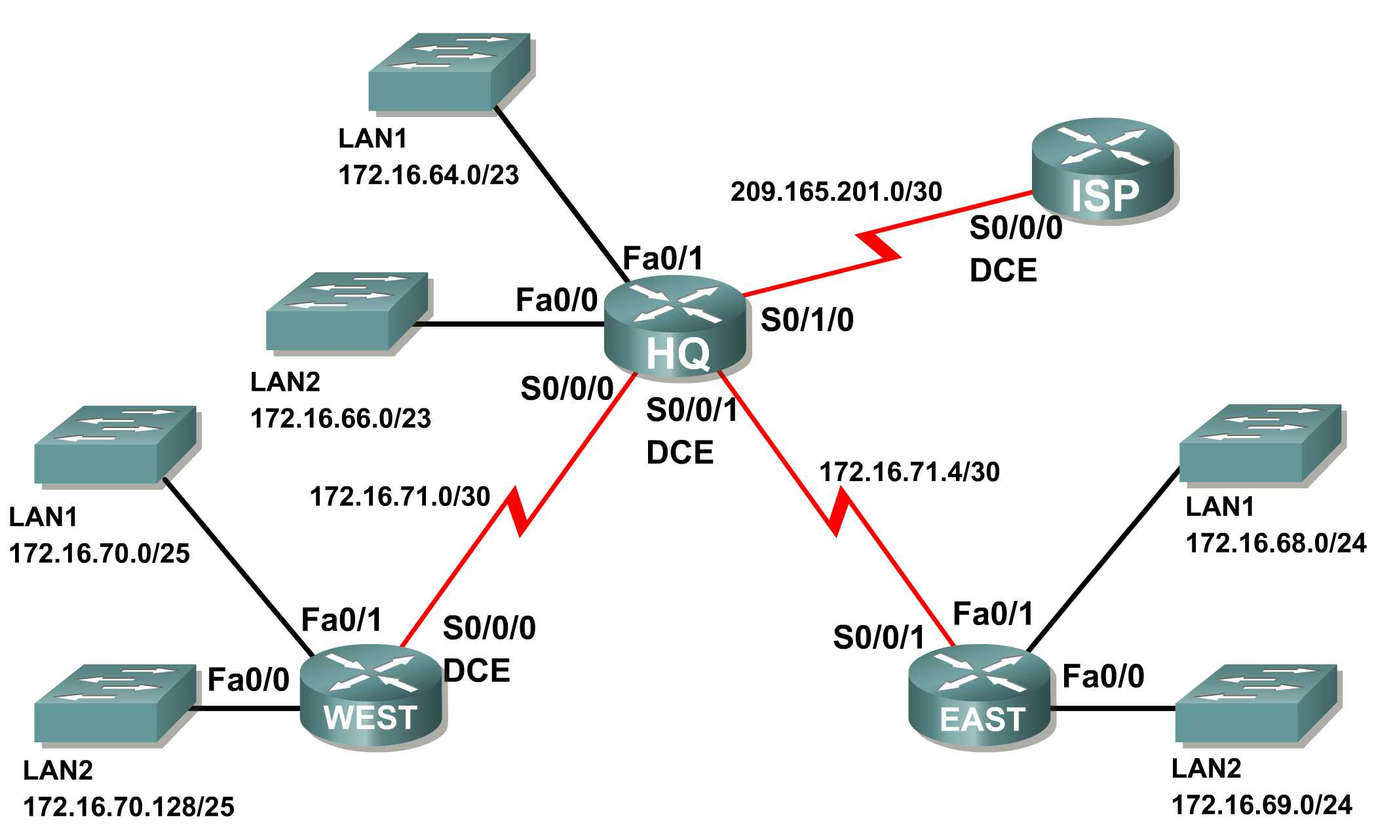
Addressing Table
Subnet | Network Address
HQ LAN1 | 172.16.64.0/23
HQ LAN2 | 172.16.66.0/23
EAST LAN1 | 172.16.68.0/24
EAST LAN2 | 172.16.69.0/24
WEST LAN1 | 172.16.70.0/25
WEST LAN2 | 172.16.70.128/25
Link from HQ to EAST | 172.16.71.4/30
Link from HQ to WEST | 172.16.71.0/30
Link from HQ to ISP | 209.165.201.0/30

Learning Objectives:
- Determine summarized routes that can be used to reduce the size of routing tables.

Scenario
In this activity, you have been given the network shown in the Topology Diagram. The subnetting and address assignments have already been completed for the network segments. Determine summarized routes that can be used to reduce the number of entries in routing tables.

Task 1: Determine the Summary Route for the HQ LANs.
Step 1: List the HQ LAN1 and LAN2 in binary format.
LAN1 ____________________________________________ 10101100.00010000.01000000.00000000
LAN2 ____________________________________________ 10101100.00010000.01000010.00000000
Step 2: Count the number of left-most matching bits to determine the mask for the summary route.
- How many left-most matching bits are present in the two networks? _______ 22
- What is the subnet mask for the summary route in decimal format? ______________________________________________ 255.255.252.0
Step 3: Copy the matching bits and then add all zeros to determine the summarized network address.
- What are the matching bits for the two networks? ______________________________________________ 10101100.00010000.01000000
- Add zeroes to make up the remainder of the network address in binary form. ______________________________________________ 10101100.00010000.01000000.00000000
- What is the network address for the summary route in decimal format? ______________________________________________ 172.16.64.0
Task 2: Determine the Summary Route for the EAST LANs.
Step 1: List the EAST LAN1 and LAN2 in binary format.
LAN1 ____________________________________________ 10101100.00010000.01000100.00000000
LAN2 ____________________________________________ 10101100.00010000.01000101.00000000
Step 2: Count the number of left-most matching bits to determine the mask for the summary route.
- How many left-most matching bits are present in the two networks? _______ 23
- What is the subnet mask for the summary route in decimal format? ______________________________________________ 255.255.254.0
Step 3: Copy the matching bits and then add all zeros to determine the summarized network address.
- What are the matching bits for the two networks? ______________________________________________ 10101100.00010000.01000100
- Add zeroes to make up the remainder of the network address in binary form. ______________________________________________ 10101100.00010000.01000100.00000000
- What is the network address for the summary route in decimal format? ______________________________________________ 172.16.68.0
Task 3: Determine the Summary Route for the WEST LANs.
Step 1: List the WEST LAN1 and LAN2 in binary format.
LAN1 ____________________________________________ 10101100.00010000.01000110.00000000
LAN2 ____________________________________________ 10101100.00010000.01000110.10000000
Step 2: Count the number of left-most matching bits to determine the mask for the summary route.
- How many left-most matching bits are present in the two networks? _______ 24
- What is the subnet mask for the summary route in decimal format? ______________________________________________ 255.255.255.0
Step 3: Copy the matching bits and then add all zeros to determine the summarized network address.
- What are the matching bits for the two networks? ______________________________________________ 10101100.00010000.01000110
- Add zeroes to make up the remainder of the network address in binary form. ______________________________________________ 10101100.00010000.01000110.00000000
- What is the network address for the summary route in decimal format? ______________________________________________ 172.16.70.0
Task 4: Determine the Summary Route for the HQ, EAST, and WEST LANs.
Step 1: List summary networks for the HQ, EAST, and WEST LANs in binary format.
HQ Summary Route ______________________________________________ 10101100.00010000.01000000.000000
EAST Summary Route ______________________________________________ 10101100.00010000.01000100.000000
WEST Summary Route ______________________________________________ 10101100.00010000.01000110.000000
Step 2: Count the number of left-most matching bits to determine the mask for the summary route.
- How many left-most matching bits are present in the three networks? _______ 21
- What is the subnet mask for the summary route in decimal format? ______________________________________________ 255.255.248.0
Step 3: Copy the matching bits and then add all zeros to determine the summarized network address.
- What are the matching bits for the three networks? ______________________________________________ 10101100.00010000.01000
- Add zeroes to make up the remainder of the network address in binary form. __________________________________________ 10101100.00010000.01000000.00000000
- What is the network address for the summary route in decimal format? ______________________________________________ 172.16.64.0

